Lab Sheet -10 CIS 31042-Practical for Data mining
Reg No :SEU-IS-19-ICT-003.
Title: Data Pre-processing and Association rule mining using Python
Aim: Missing Value handling
Data Pre-processing
Association rule mining
Task: Finding the Frequent item set
Association rule mining Exercises:
- Import the numpy and pandas libraries
- load the data set ls-01
- Create the two copies of the data set
- Check the null values
- Missing data handling
- Remove the missing values
- Filling the missing values
- Group the data
- Label the missing values
- Group the data according to the gender
- Import the data set as
- Dataset=[[‘milk’,’onion’,’nugmeg’,’kidney beans’,’eggs‘,’yogurt’],
[‘oill’,’onion’,’nutmeg’, ’kidney beans’,’eggs‘,’yogurt’],
[‘milk’,’apple’, ’kidney beans’,’eggs‘],
[‘milk’,’unicorn’,’corn’,’kidney beans’, ’yogurt’]
[‘corn’,’onion’,’onion’ , ’kidney beans’,’ice cream’,’eggs‘]]
- Import the pandas and mlxtend libraries
- Create the dataset as a dataframe
- Create the possible item set for the min_support=0.6 using apriori algorithum
- Create the association rule mining
- Create the sub set of antecedents,consequents,support,confidence,lift
- Retrieve the itemset which itemset have confidence >= 1

Exercise
- Import the numpy and pandas libraries


- load the data set ls-01
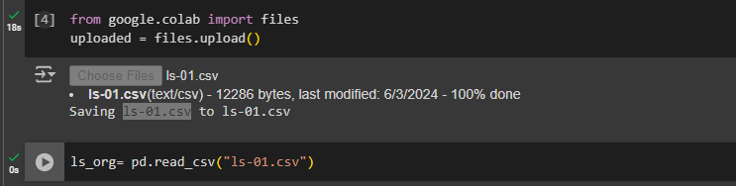

- Create the two copies of the data set


- Check the null values
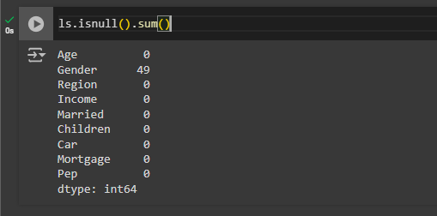

- Missing data handling
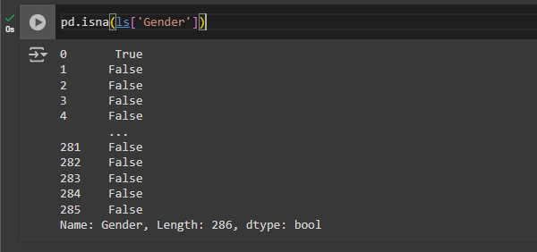

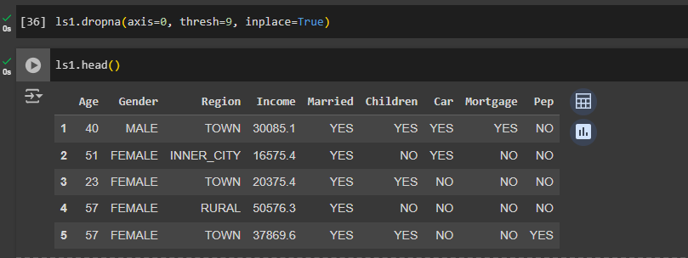
- Remove the missing values

- Filling the missing values
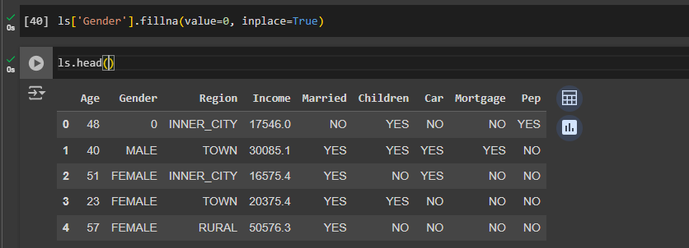

- Group the data
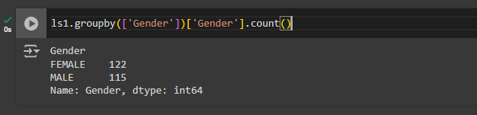

- Label the missing values
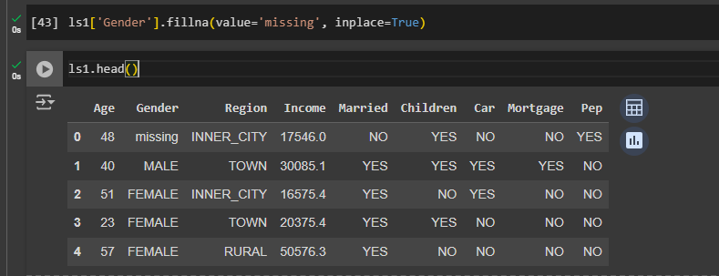

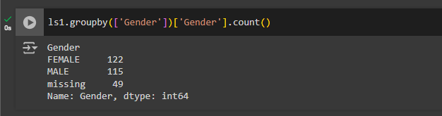
- Group the data according to the gender

- Import the data set as
- Dataset=[[‘milk’,’onion’,’nugmeg’,’kidney beans’,’eggs‘,’yogurt’],
[‘oill’,’onion’,’nutmeg’, ’kidney beans’,’eggs‘,’yogurt’],
[‘milk’,’apple’, ’kidney beans’,’eggs‘],
[‘milk’,’unicorn’,’corn’,’kidney beans’, ’yogurt’]
[‘corn’,’onion’,’onion’ , ’kidney beans’,’ice cream’,’eggs‘]]
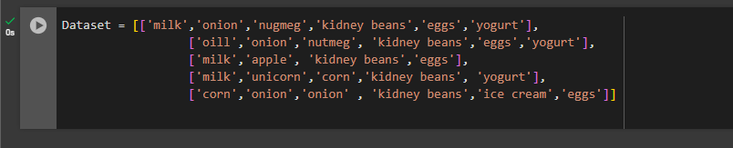

- Import the pandas and mlxtend libraries
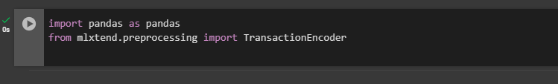

- Create the dataset as a dataframe
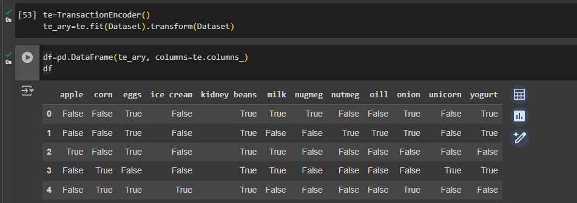

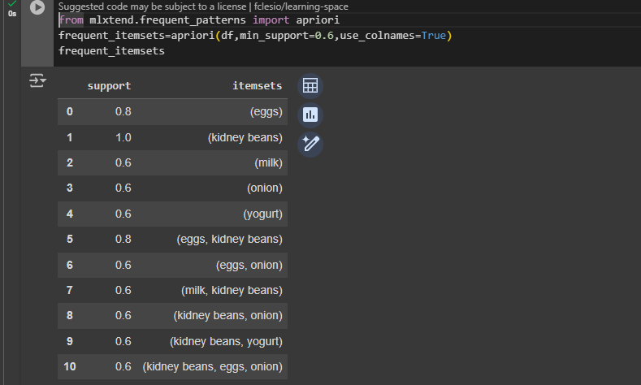
- Create the possible item set for the min_support=0.6 using apriori algorithum

- Create the association rule mining
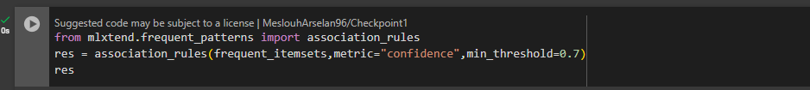
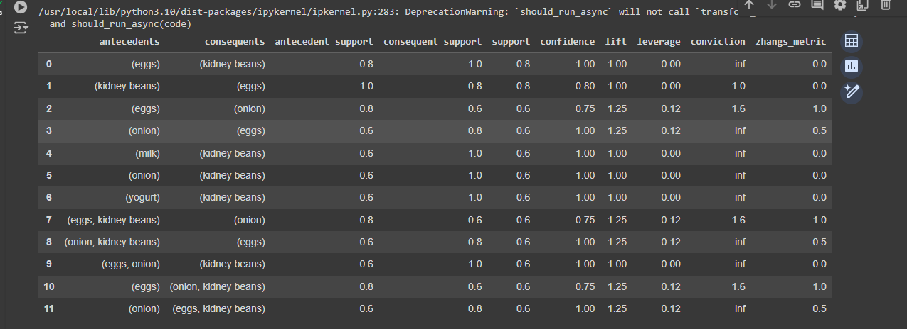

- Create the sub set of antecedents,consequents,support,confidence,lift
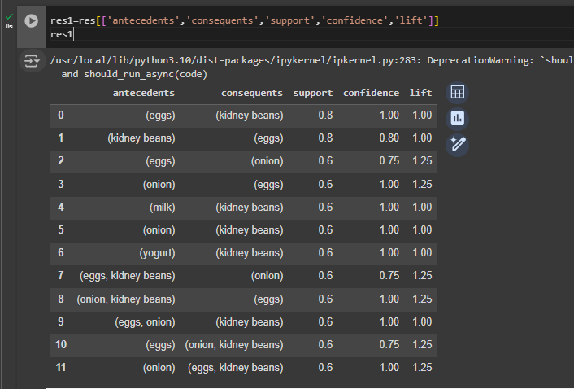

- Retrieve the itemset which itemset have confidence >= 1
